**OOM APPLET ASSIGNMENT – 1**

**Name: Aditya Aggarwal Roll Number: IIT2019210**

**Q1) Write a program to display an animation of a bouncing ball using a Java applet.**

**Code:**

package first;  
  
import java.applet.*;  
import java.awt.*;  
  
public class BouncingBall extends Applet implements Runnable  
{  
 *// Defining x,y coordinates and radius of the circle* int x = 160, y = 50, r=20;  
 int dx = 11, dy = 7;  
  
 *// create thread* Thread t;  
 boolean stopFlag;  
  
 public void start()  
 {  
 t = new Thread(this);  
 stopFlag=false;  
 t.start();  
 }  
  
 public void paint(Graphics g)  
 {  
 g.setColor(Color.*red*);  
 g.fillOval(x-r, y-r, r*2, r*2);  
 }  
  
 public void run()  
 {  
 while(true)  
 {  
 if(stopFlag)  
 break;  
 *// Bounce if we've hit an edge* if ((x - r + dx < 0) || (x + r + dx > bounds().width)) dx = -dx;  
 if ((y - r + dy < 0) || (y + r + dy > bounds().height)) dy = -dy;  
 *// Move the circle* x += dx; y += dy;  
  
 try  
 {  
 Thread.*sleep*(100);  
 }  
 catch(Exception e)  
 {  
 System.*out*.println(e);  
 };  
 repaint();  
 }  
 }  
  
 public void stop()  
 {  
 stopFlag=true;  
 t=null;  
 }  
}

**Sample Output:**

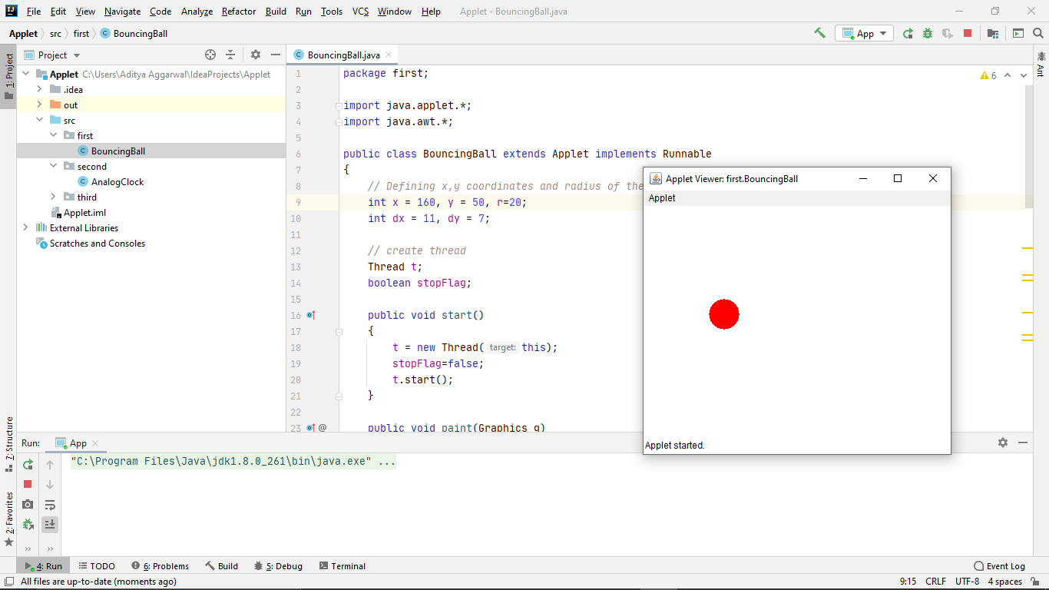

**Q2) Write a program to display an analog clock using Applet. Also display the time in digital format below the analog clock in 12 hour format.**

**Code:**

package second;  
  
import java.applet.Applet;  
import java.awt.*;  
import java.util.*;  
  
public class AnalogClock extends Applet {  
  
 @Override  
 public void init()  
 {  
 this.setSize(new Dimension(800, 400));  
 setBackground(new Color(50, 50, 50));  
 new Thread() {  
 @Override  
 public void run()  
 {  
 while (true) {  
 repaint();  
 delayAnimation();  
 }  
 }  
 }.start();  
 }  
  
 private void delayAnimation()  
 {  
 try {  
  
 Thread.*sleep*(1000);  
 }  
 catch (InterruptedException e) {  
 e.printStackTrace();  
 }  
 }  
  
 @Override  
 public void paint(Graphics g)  
 {  
 Calendar time = Calendar.*getInstance*();  
  
 int hour = time.get(Calendar.*HOUR_OF_DAY*);  
 int minute = time.get(Calendar.*MINUTE*);  
 int second = time.get(Calendar.*SECOND*);  
  
 if (hour > 12) {  
 hour -= 12;  
 }  
  
 g.setColor(Color.*white*);  
 g.fillOval(300, 100, 200, 200);  
  
 g.setColor(Color.*black*);  
 g.drawString("12", 390, 120);  
 g.drawString("9", 310, 200);  
 g.drawString("6", 400, 290);  
 g.drawString("3", 480, 200);  
  
 double angle;  
 int x, y;  
  
 angle = Math.*toRadians*((15 - second) * 6);  
  
 x = (int)(Math.*cos*(angle) * 100);  
 y = (int)(Math.*sin*(angle) * 100);  
  
 g.setColor(Color.*red*);  
 g.drawLine(400, 200, 400 + x, 200 - y);  
  
 angle = Math.*toRadians*((15 - minute) * 6);  
  
 x = (int)(Math.*cos*(angle) * 80);  
 y = (int)(Math.*sin*(angle) * 80);  
  
 g.setColor(Color.*blue*);  
 g.drawLine(400, 200, 400 + x, 200 - y);  
  
 angle = Math.*toRadians*((15 - (hour * 5)) * 6);  
  
 x = (int)(Math.*cos*(angle) * 50);  
 y = (int)(Math.*sin*(angle) * 50);  
  
 g.setColor(Color.*black*);  
 g.drawLine(400, 200, 400 + x, 200 - y);  
 }  
}

**Sample Output:**

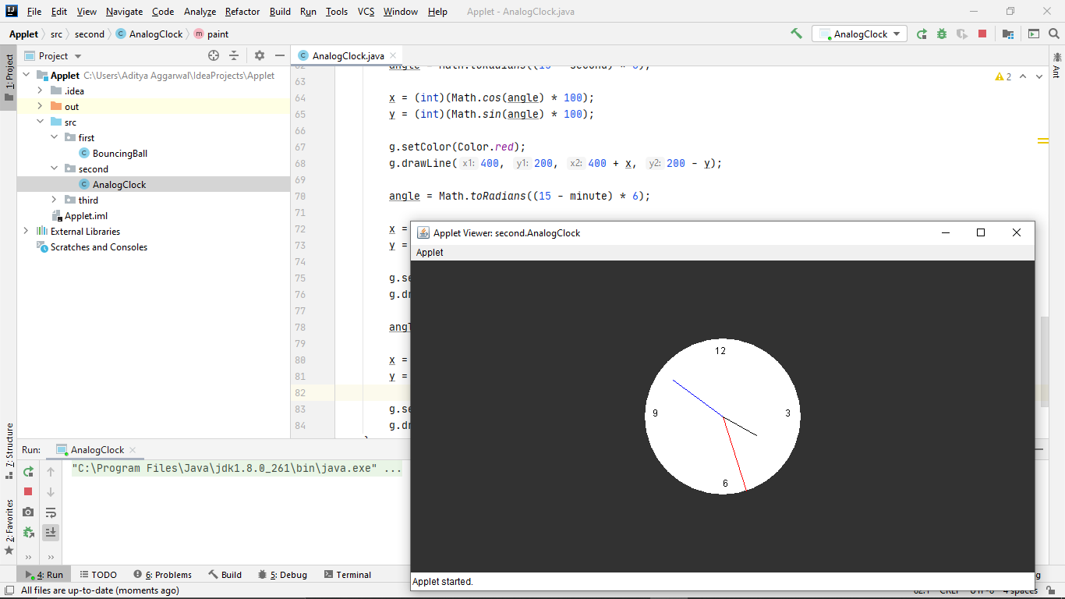

**Q3) Write a program to let the HTML Author Supply Data to display a webpage similar to below, using HTML and Applet. Write the applet code to provide appropriate colors for the LIGHT and DARK values provided to the BACKGROUND.**

**Codes:**

**Java Applet code:**

package third;  
  
import java.applet.Applet;  
import java.awt.*;  
*/*<applet code="LinkHTML" width=300 height=300 ></applet>*/*public class LinkHTML extends Applet {  
 String str;  
 public void init() {  
 Color background = Color.*GRAY*;  
 Color foreground = Color.*DARK_GRAY*;  
 String backgroundType = getParameter("BACKGROUND");  
 if (backgroundType != null) {  
 if (backgroundType.equalsIgnoreCase("LIGHT")) {  
 background = Color.*WHITE*;  
 foreground = Color.*BLACK*;  
 } else if (backgroundType.equalsIgnoreCase("DARK")) {  
 background = Color.*BLACK*;  
 foreground = Color.*WHITE*;  
 }  
 }  
 str="Hello, World Wide Web.";  
 setBackground(background);  
 setForeground(foreground);  
 }  
  
 public void paint(Graphics g)  
 {  
 g.setFont(new Font("TimesRoman", Font.*PLAIN*, 30));  
 g.drawString(str, 4, 30);  
 }  
}

**HTML File Code:**

<!DOCTYPE html>  
<html lang="en">  
<head>  
 <meta charset="UTF-8">  
 <title>Customizable Hello WWW Apple</title>  
</head>  
<body>  
 <h1>Customizable Hello WWW Applet</h1>

<applet code="third/LinkHTML.class" height=50 width=400>  
 <param name="BACKGROUND" value="LIGHT">  
 </applet>

<br><br>

<applet code="third/LinkHTML.class" height=50 width=400>  
 <param name="BACKGROUND" value="DARK">  
 </applet>

<br><br>

<applet code="third/LinkHTML.class" height=50 width=400>

</applet>

</body>  
</html>

**Sample Output of Applet Webpage:**

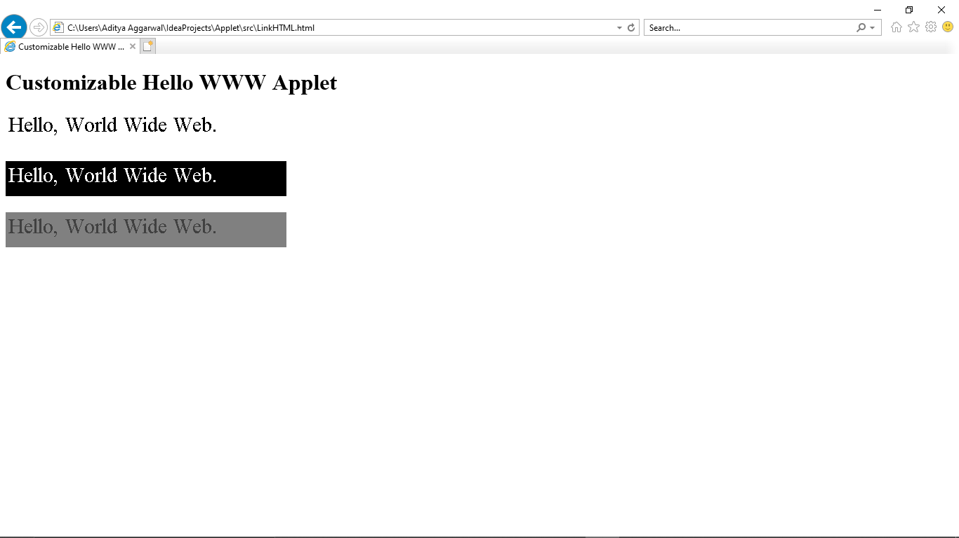

**Sample Output from Applet Viewer:**

